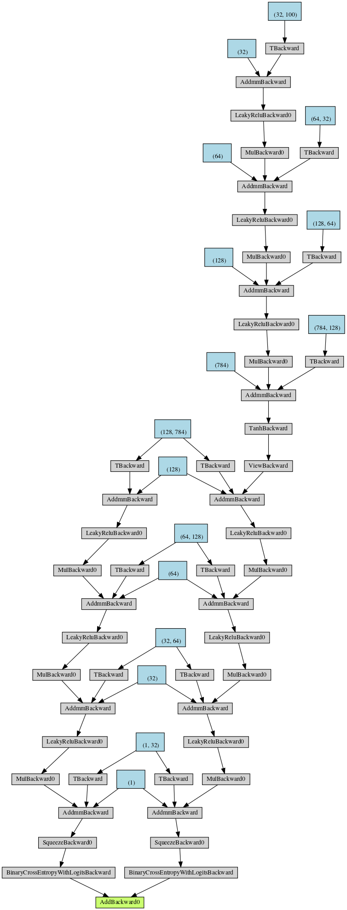
These are computational graphs from a MNIST GAN

This is the computational graph without using detach

So when we calculate backward on this it will calculate gradients for all
the weights in discriminator and generator

But after calculating the gradients PyTorch clears out all the variables
(that is intermediate values in computational graph )

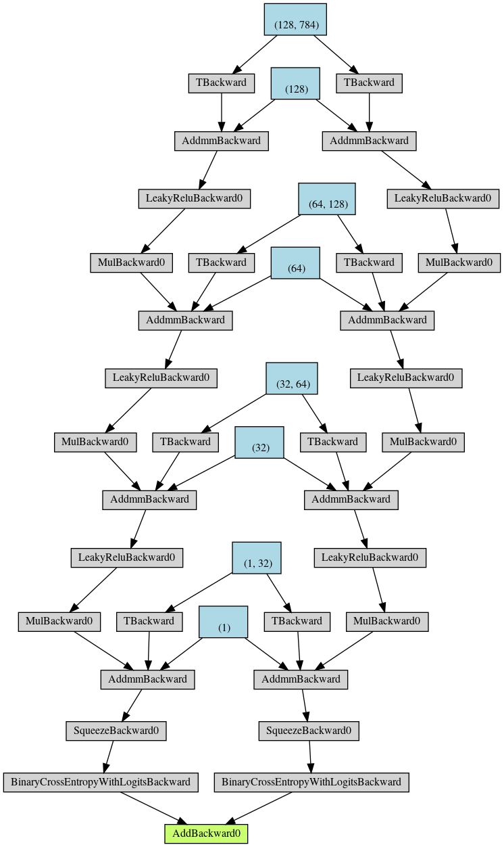

This is the computational graph after using .detach() on fake ,
note that what .detach() has done is detaching history of fake
from computational graph

So when we do a backward pass on this it will give gradients
w.r.t discriminator parameters (so this will not clear out
variables in the generator)

N.B – we want the generator variables later to calculate the gradients w.r.t generator parameters

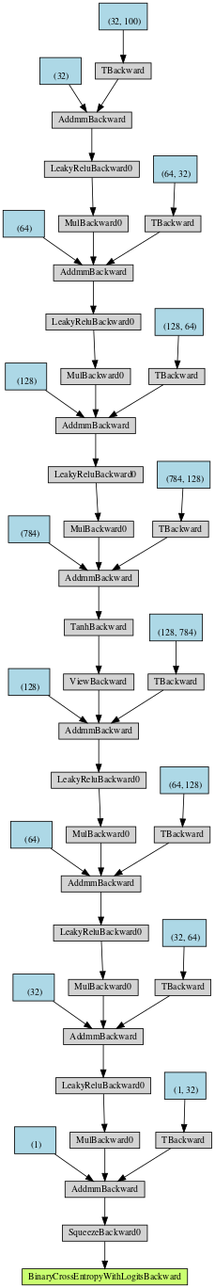

This is the how we calculate the loss of fakes in the generator .
Note that because we did use detach there is still fake computation graph in this

(Note the part in red is the generator )

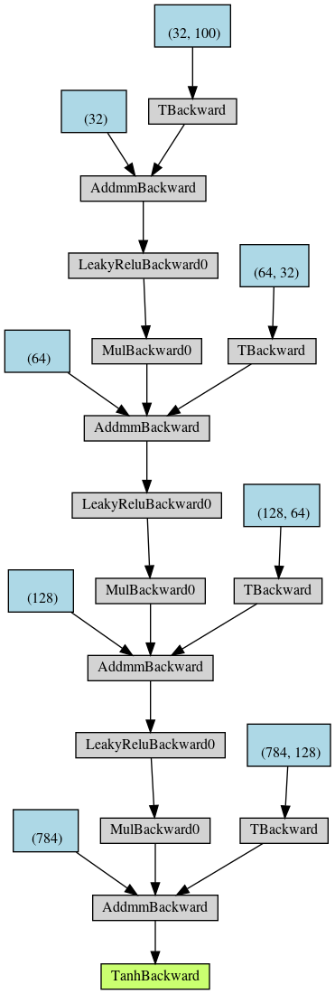
This is the part that detach will remove from the computation graph first

Because PyTorch defaults to calculate the back propagation only once for a calculation graph. After back propagation, the memory of this calculation graph is released

According to the chain rule, the parameter gradient of the discriminator has to be calculated, although it will not be updated at this step. Discriminator parameters. After the back-propagation, the noise, the fake image, and then the output of the discriminator, the computation graph of the forward propagation, are released and will not be used later.

discriminator(gen_imgs.detach()), detach means that the data and the calculation graph that generated it are "detached", that is, the gradient It stopped at that place, and it no longer continues to propagate forward (in fact, it will not propagate forward anymore, because the generator's computation graph is released after the first backpropagation). Therefore, the discriminator gradient back propagates to itself

